The road to hellbender recovery requires persistence and long-term effort

“Well, hello there! It looks like he or she is still under this rock and doing well!” announced Julia Golias (Ohio University, Wildlife and Conservation BSc 2019), extracting a small waterproof video camera from under a rock the size of a car hood. Julia, along with a team of Ohio University Biological Sciences researchers led by PhD student Matt Kaunert and Dr. Viorel Popescu (currently Ohio University affiliate), has been monitoring an iconic Appalachian species, the Eastern Hellbender in several Ohio streams. This research is part of a statewide effort to repatriate Eastern Hellbenders to Ohio and help rebuild their numbers. The effort is led by the Ohio Division of Wildlife and the Ohio Hellbender Partnership, a coalition of wildlife managers, conservation practitioners, husbandry experts and academics committed to recovering this species in Ohio. Once common in Appalachian streams, Eastern Hellbenders have declined dramatically due to altered stream habitat and watershed conditions and are listed as Endangered in Ohio and other states across Appalachia. As such, Eastern Hellbenders, which can reach up to 2 feet in length and live up to 40 years, are sentinels of stream health and drinking water quality, and their disappearance is an indicator of impaired streams.
ADD PHOTO OF HELLBENDER

Eastern Hellbender in its natural habitat (photo: Justin Grubb, Wild Lens Collective)
In a new study published open-access in the journal Population Ecology, Kaunert and team report on the fate of repatriated Eastern Hellbenders and use simulations to provide insights into the best strategies to rebuild Eastern Hellbender populations. Their 4-year field study aimed to understand the survival of headstart hellbenders raised in captivity at several Ohio zoos and released in their former stream habitat. “Most wild hellbender populations in Ohio and other states witnessing severe declines, seem to lack successful recruitment. Headstarting, which involves collecting wild eggs that are already fertilized, raising animals in captivity until they are 3-4 years old and releasing them back in the wild has become the norm in hellbender conservation” says Kaunert. “We do not fully understand the mechanisms behind reduced recruitment, but we suspect that most animals do not make it past the egg or larval stage. As such, releasing larger animals back into the streams (aka headstarted animals) gives them a leg up and helps them skip a very sensitive period of their life”.
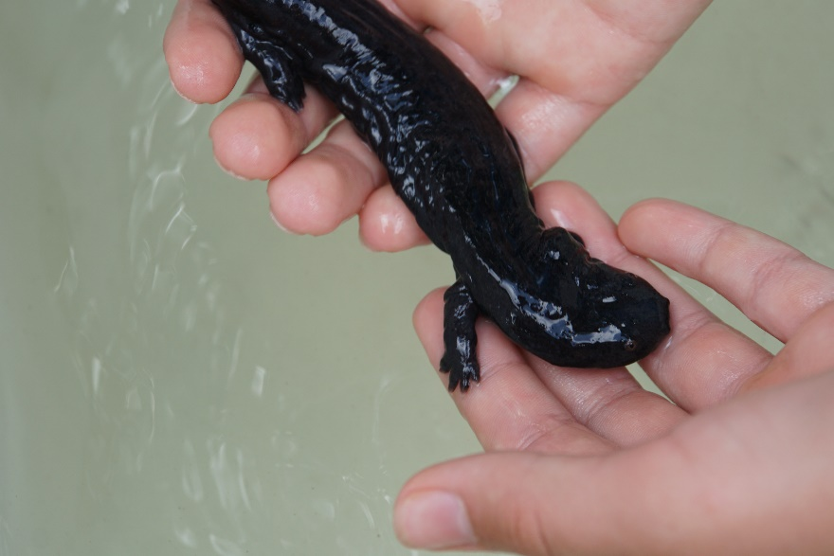
Young hellbender ready to be released in Ohio streams in 2018 (photo: Viorel Popescu)


OHIO students participating in hellbender releases in 2018 (photo: Viorel Popescu)

The Ohio University researchers received funding from the Ohio Division of Wildlife (2018-2022) and partnered with Columbus Zoo, Toledo Zoo and Penta Career Center, three facilities in Ohio that have been raising hellbenders in captivity for many years, as well as other Ohio amphibian experts to monitor the fate of 200+ headstart hellbenders released in several streams in 2018. Animals traveled to the release locations in aerated coolers, where students and collaborators released them one by one under large rocks. Each hellbender was implanted with a Passive Integrated Transponder tag (or PIT tag), which gives a unique code to each animal. Ohio University researchers monitored the released animals via 25 recurring surveys at the release locations between August 2018 and July 2022. They scanned the bottom of the streams using a receiver and antenna that can penetrate down to 1 foot through rock, water or pebbles to ‘read’ the PIT tag unique number. “This was tough work and we had to time the surveys to exclude high water levels. Each time we detected a tag, and we were able to confirm the presence of the animal via an underwater video camera, we were exulted! When animals were found under smaller rocks, we attempted to catch the animal no more than (once per year) and assess its health and growth”, says Ryan Brown, co-author of the study. Some animals established successfully and were present at the release locations throughout the study period.
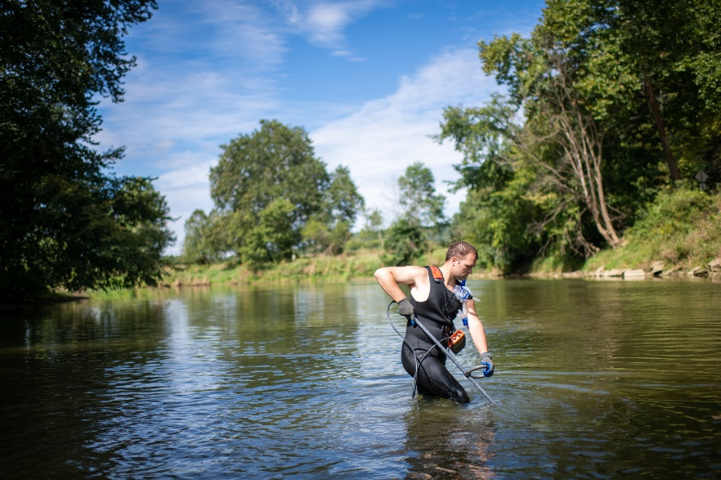
Andrew Travers (OHIO Wildlife and Conservation ‘20) conducting PIT tag surveys to detect repatriated hellbenders (photo: Ben Siegel)
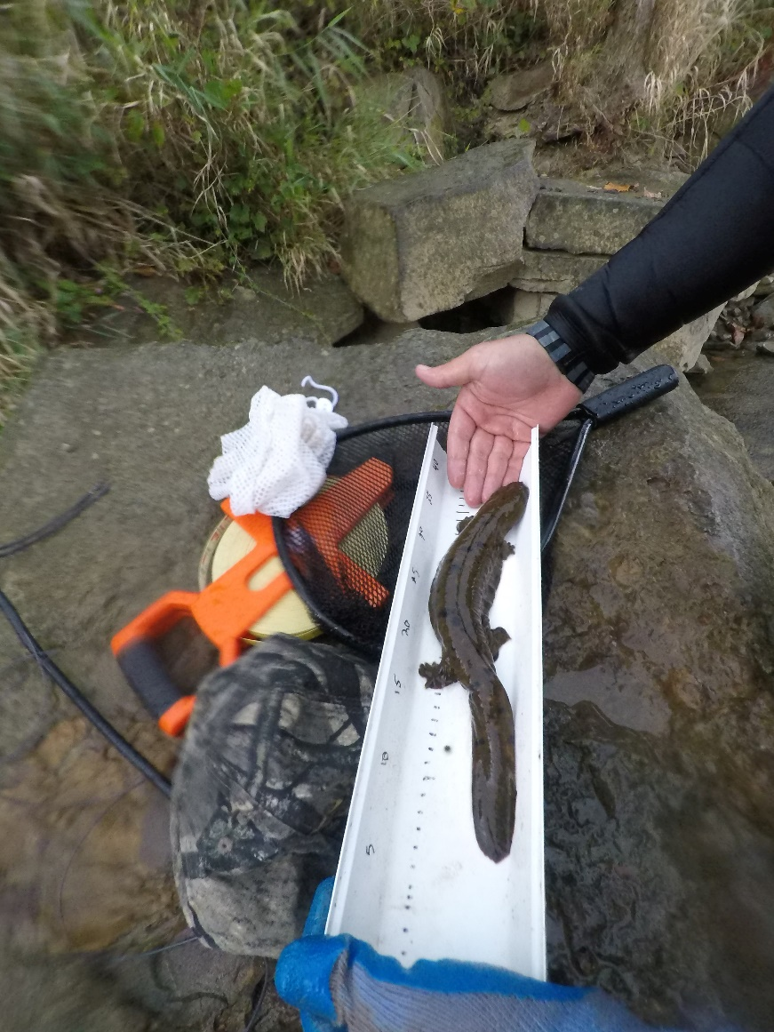
Repatriated Ohio hellbender detected and captured 1-year post release (photo: Viorel Popescu)

However, animals persisted at the release locations with mixed success. Of 8 total release locations, researchers were able to monitor 3 streams that had consistent PIT tag detections through the study period. Researchers found that survival at the 3 sites was ~40% after the first year and ~60% in subsequent years, yielding a total survival of ~17% from release to the end of 4-year study. The survival estimates are “apparent”, meaning that they cannot discern between true mortality and movement outside the monitored reaches. “This may seem like low survival, but these numbers are not that different from survival of wild hellbenders of the same age, and lower survival is typically expected of repatriated animals”, says Popescu. “We do not know what happened to the animals at the other reaches and whether the animals are truly dead or moved outside the monitoring areas. It is likely that some animals were able to get deep in the substrate and we were not able to detect them, or that some animals drifted downstream outside the release reaches. However, if the animals stayed at the release sites, the likelihood of not detecting animals after 20+ surveys is very low. Also, because they are so rare, if these animals are indeed alive, but do not return to the release location where small populations have established, they are effectively dead to the population, as they would not be contributing to reproduction.”
In addition to these findings, the researchers used survival values from this study and literature and simulated population persistence to understand how many animals and how often should they be released in order to build viable populations. They found that at least 2 (ideally 3) releases at the same site using groups of 100 headstart individuals would be required to build viable breeding adult populations (15-30 adults). This finding is important as repatriation headstarting and continues to be the main strategy for hellbender recovery in Ohio, Indiana, New York and other states, and provides guidance for allocating effort and resources.

To date, more than 1900 headstart animals have been released in Ohio streams in the past 10 years. This is an incredible achievement, yet better understanding of the fate of repatriated animals and the sustainability of these efforts is needed. The good news is that Ohio recorded the first ever breeding event of a repatriated hellbender in the US! In August 2023, Hannah Kopp (Ohio University BSc Wildlife and Conservation 2021), Watershed Program Manager at NGO Rural Action, found a male hellbender guarding a clutch of eggs in an artificial nest box installed by Ohio University researchers. The Ohio state herpetologists confirmed that it was a headstart animal released in 2016 in the immediate vicinity of the nest box. This is an incredible milestone and speaks to the importance of repatriation program for rebuilding Ohio hellbender populations.
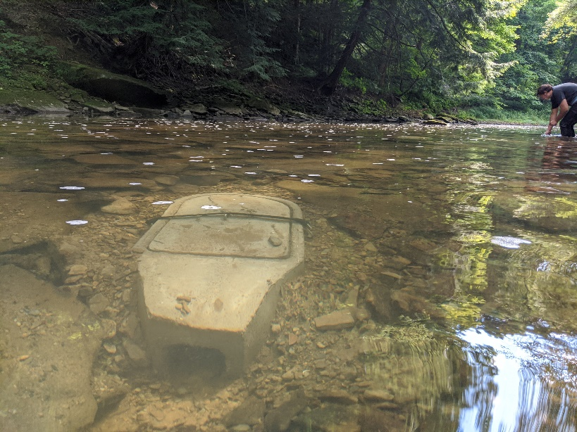
Nest box deployed in an Ohio stream (photo: Viorel Popescu)
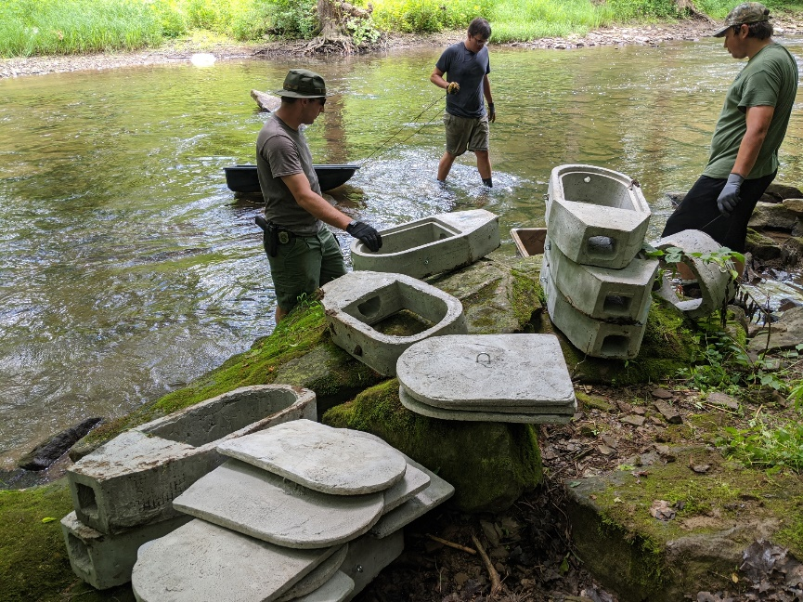
Nest box deployment was a huge effort and involved Ohio University students, Ohio Division of Wildlife personnel, watershed managers and other volunteers. Ohio University deployed more than 180 nest boxes in Ohio (photo: Viorel Popescu)

“The take home message of this study is to not be deterred by the low survival of headstart hellbenders. Just like hellbenders persisted for 10’s of millions of years, we also have to be persistent in our efforts to bring them back. Our study showed that headstarting is a good conservation strategy when wild recruitment is low. Since hellbenders can live 30-40 years, so we also need to take a long-term approach to their recovery and continue rebuilding populations.”, concludes Kaunert The goal is to re-establish breeding populations, but repatriation is only one piece of the puzzle. The other critical piece is watershed conservation and improvement in water quality and practices that impact water quality. Hellbenders remained largely unchanged for 150 million years but are still very sensitive to altered water quality. The study has ended, but the research team continues to be involved in hellbender stewardship in Ohio; they are joining forces with NGO Rural Action and USDA Natural Resource Conservation Service to understand more about water quality in hellbender streams and provide analytical support for other projects aimed at hellbender recovery.

Publication:
Kaunert, M. D., R. K. Brown, S. Spear, P. B. Johantgen, and V. D. Popescu. 2023. Restoring Eastern hellbender (Cryptobranchus a. alleganiensis) populations through translocation of headstarted individuals. Population Ecology n/a. https://doi.org/10.1002/1438-390X.12171

